IT314

Lab 7 & 8 - UML Diagrams

Group: - 17

|  |  |
| --- | --- |
| Name | ID |
| Axit Dhola | 201901004 |
| Keval Savaliya | 201901006 |
| Sanny Dhameliya | 201901031 |
| Bhadrayu Bhalodia | 201901049 |
| Dhruvil Gorasiya | 201901061 |
| Kenil Bhingradiya | 201901066 |

1. Class Diagram

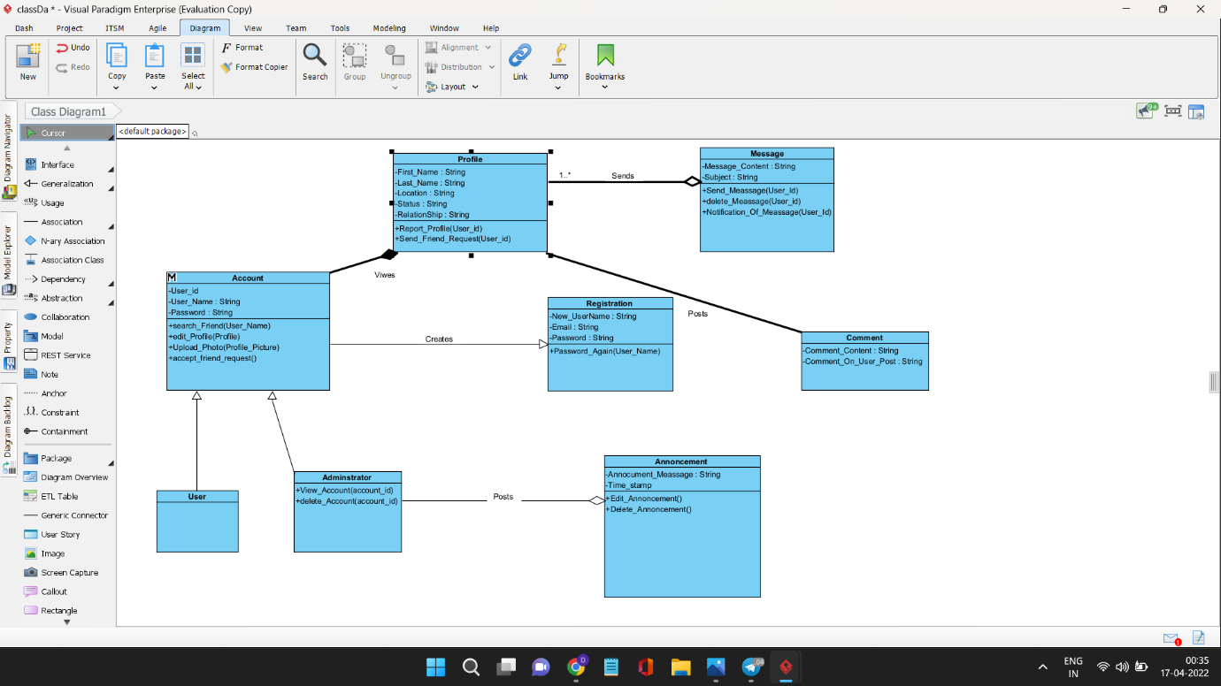

1. Object Diagram

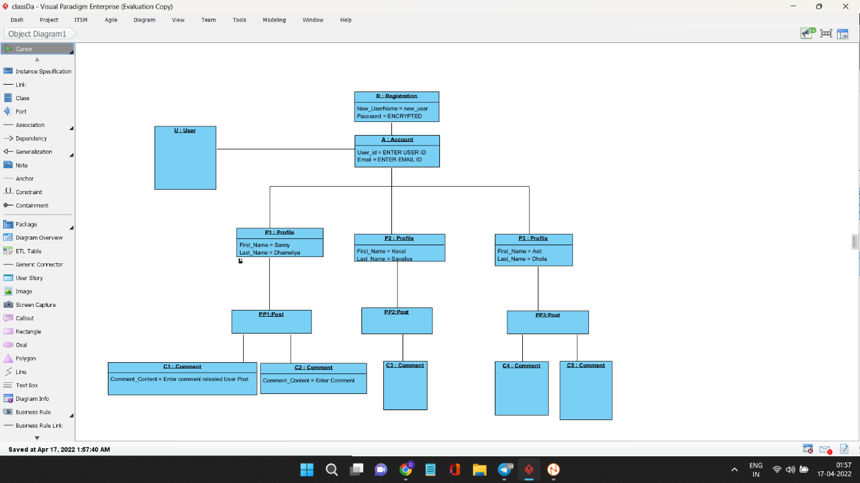

1. Component Diagram

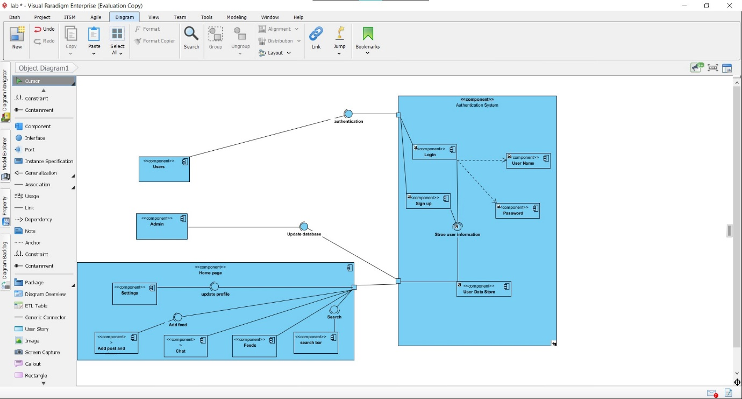

1. Deployment Diagram

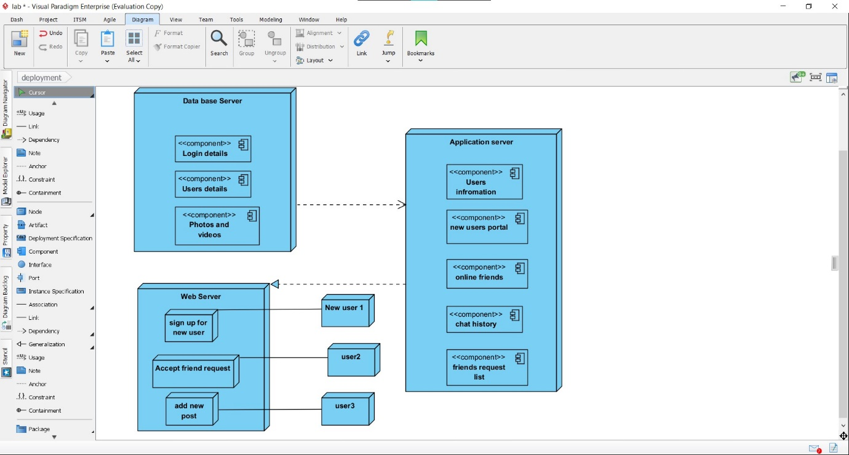

1. Package Diagram

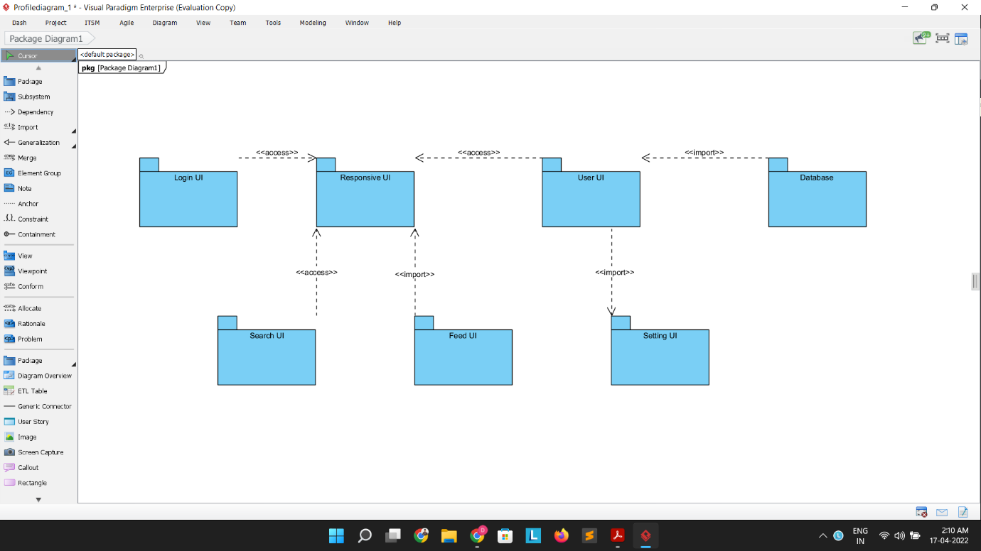

1. Profile Diagram

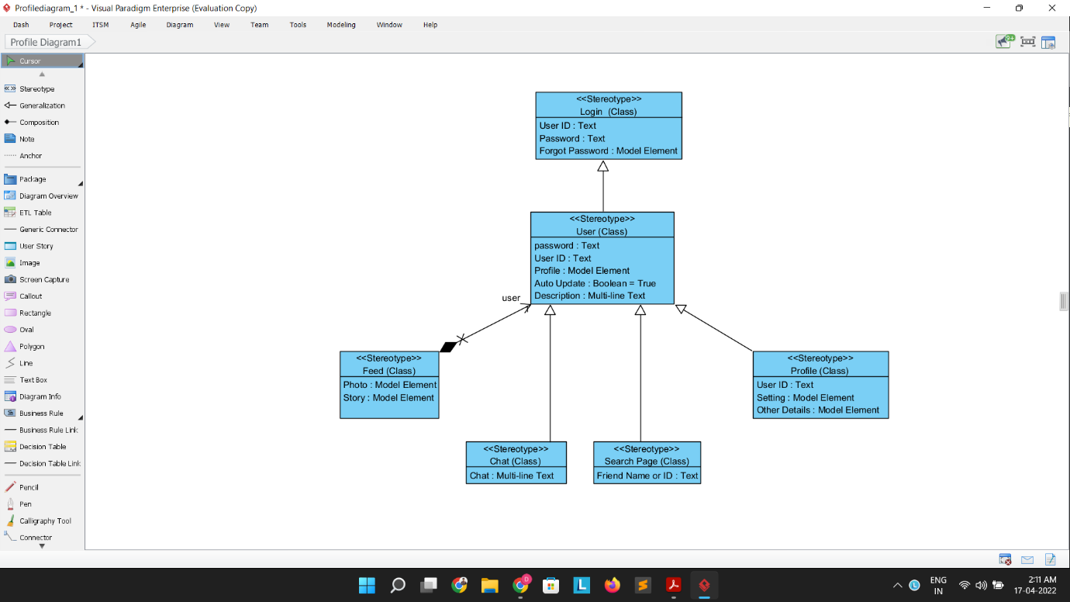

1. Composite Structure Diagram

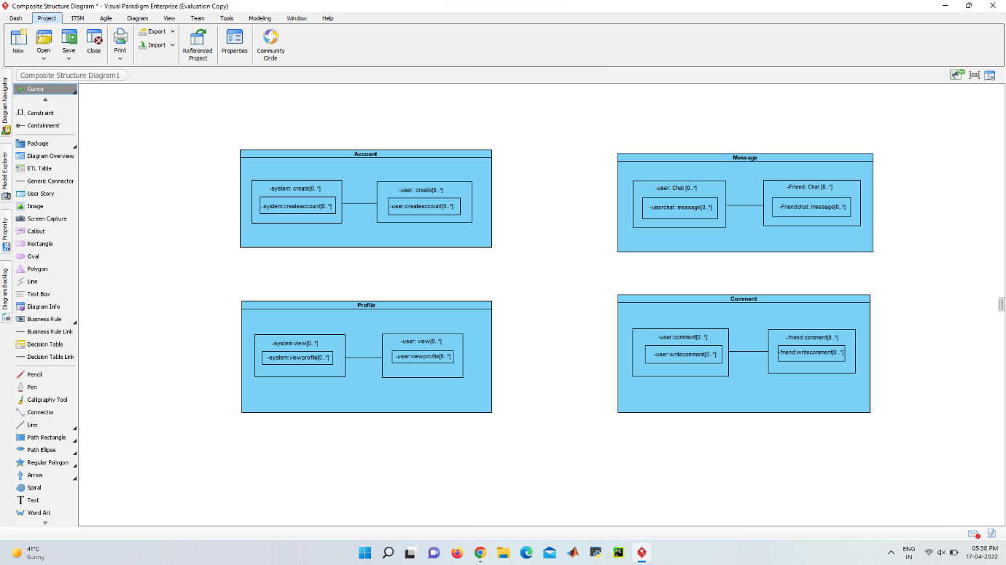

**Behavioral Diagrams**

1. State Machine Diagram

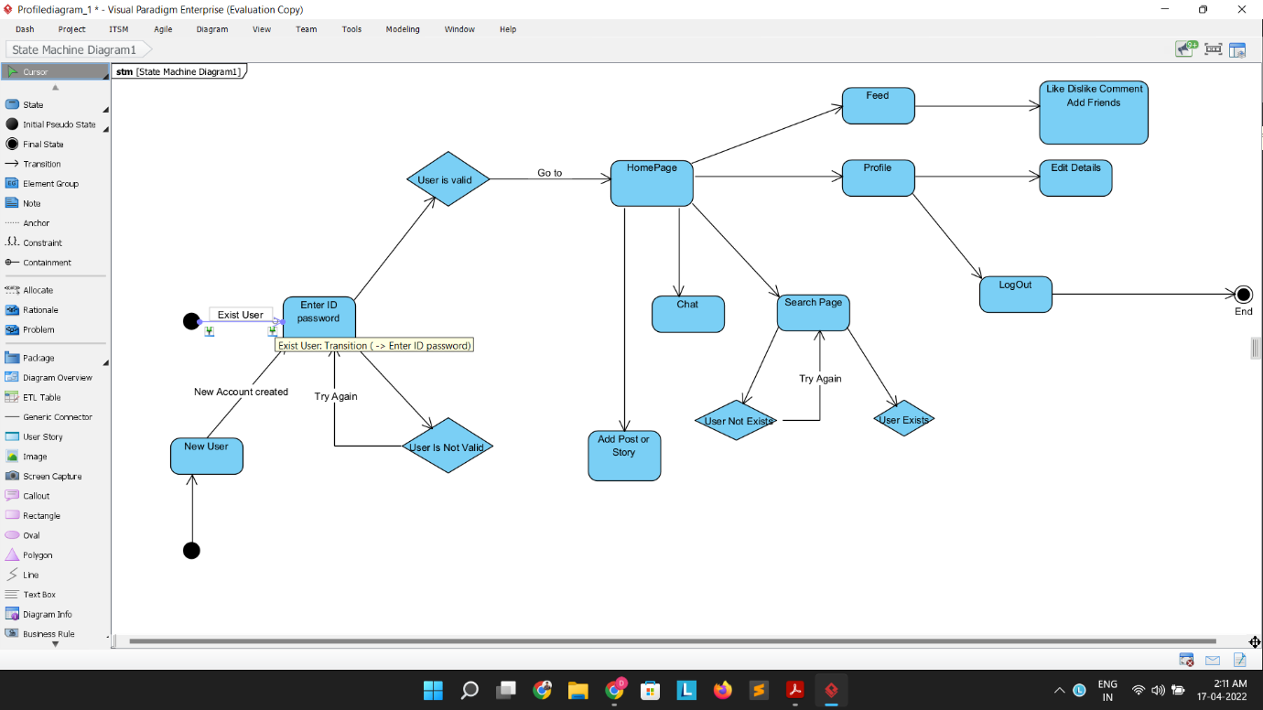

1. Communication Diagram

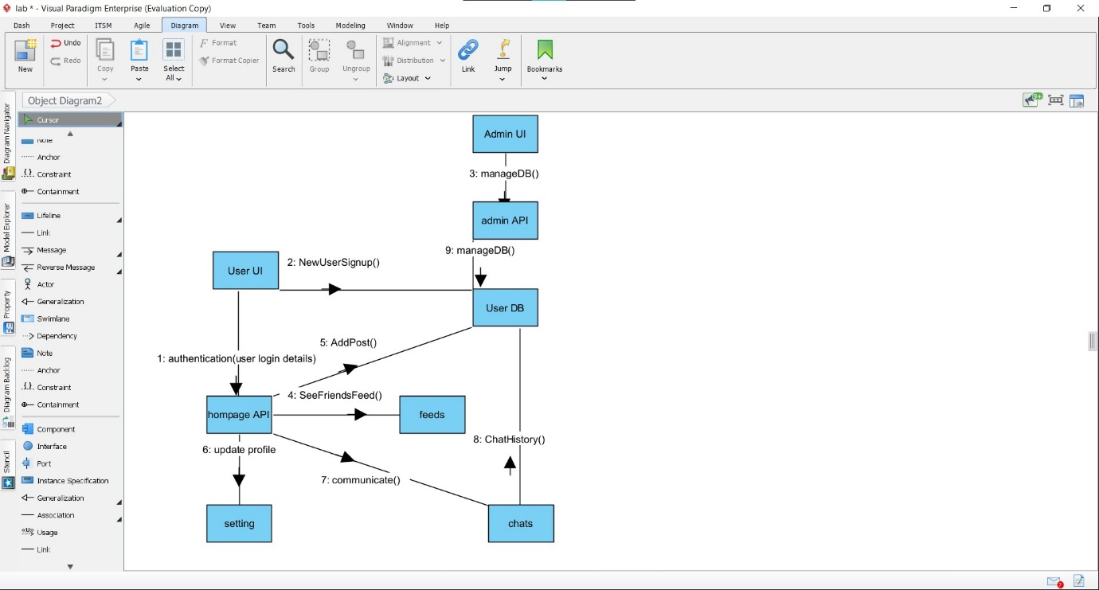

1. Use Case Diagram

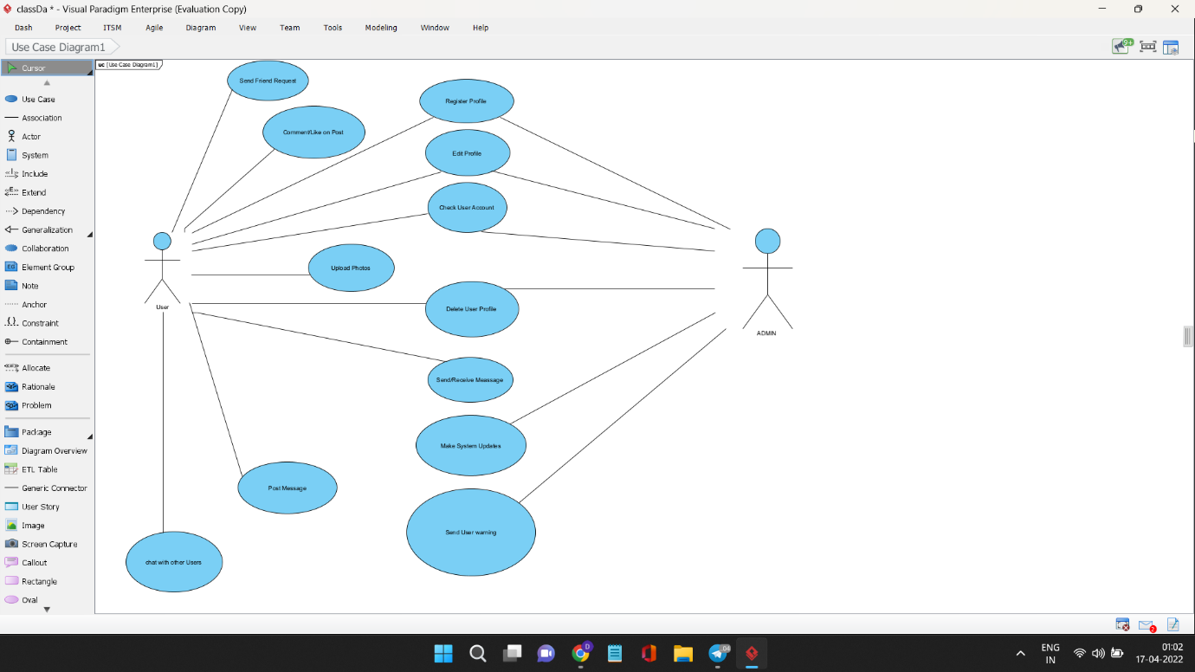

1. Activity Diagram

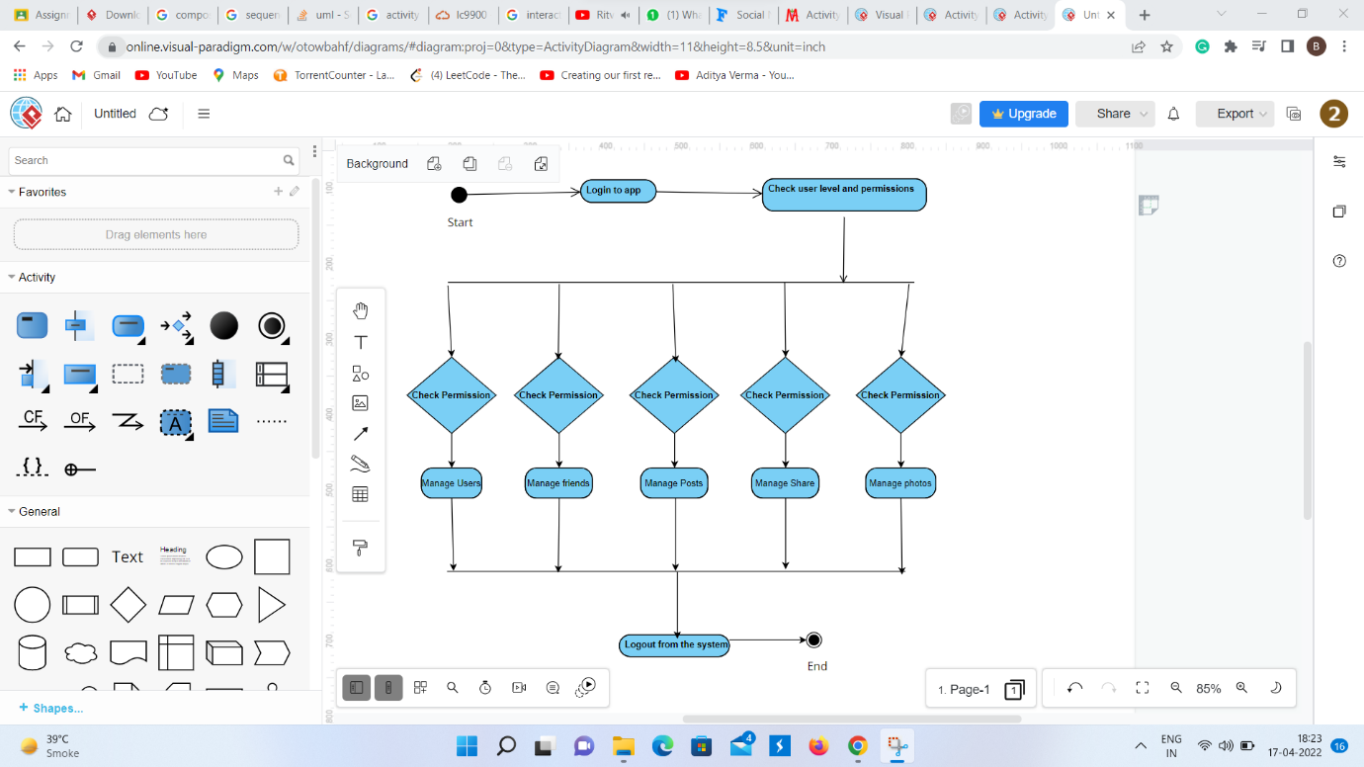

1. Sequence Diagram

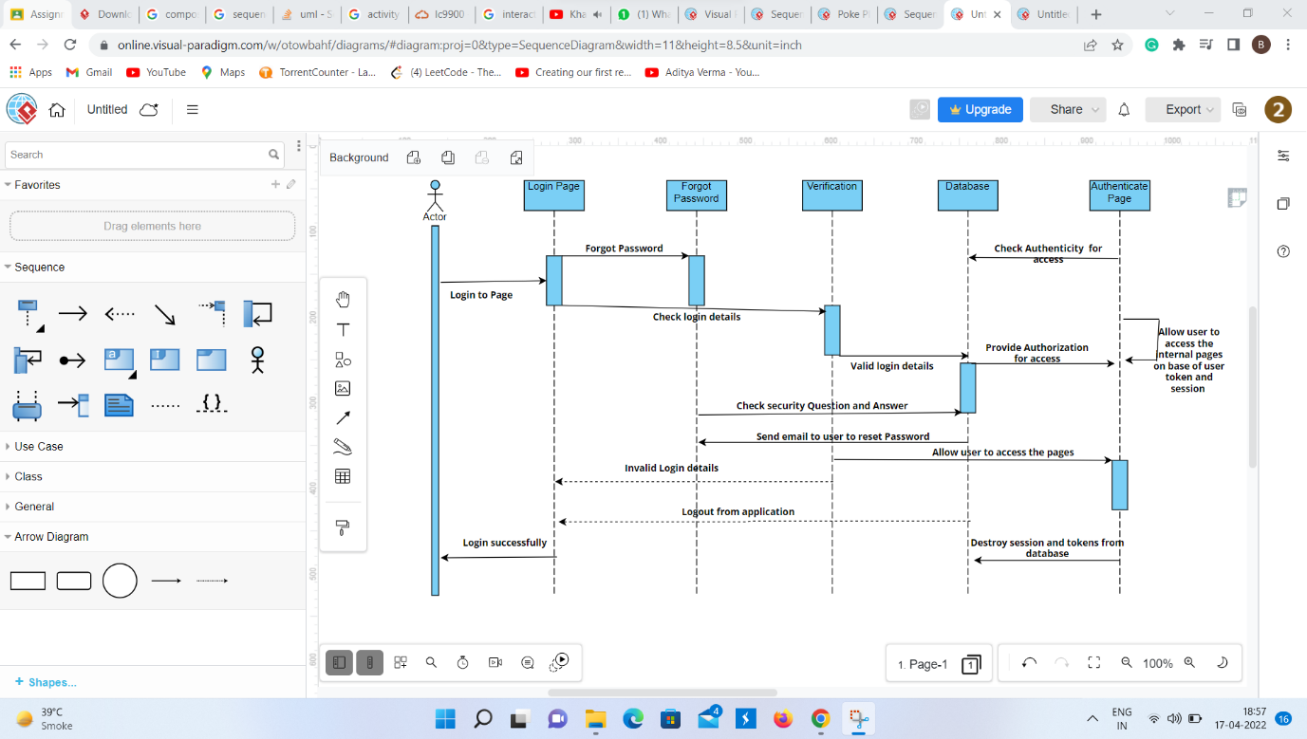

1. Timing Diagram

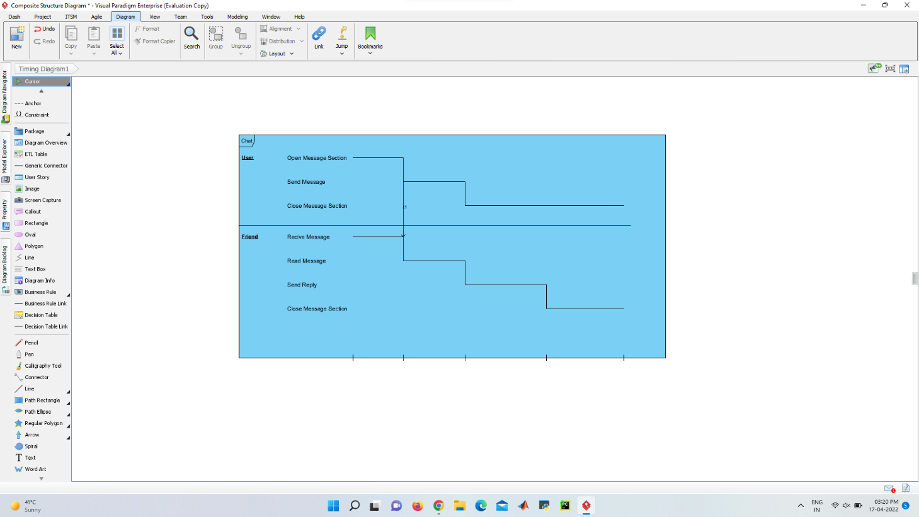

1. Interaction Overview Diagram

